OCTOBER is
COLLEGE KNOWLEDGE MONTH!

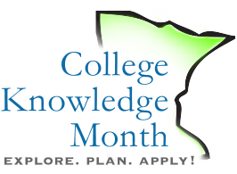 | WHO? Class of 2015 and students who want to PLAN, EXPLORE, and APPLY to college!
 | WHAT? Seniors across the state learning about applying to colleges and universities – and starting to do just that.
WHERE? | NAME OF SCHOOL, ROOM NUMBER
WHEN? | DATE AND TIME OF EVENT
WHY? | Studies show that if you continue your education beyond high school:  - You will make more money in your lifetime  - You will be less likely to be unemployed  - You will be more likely to have better health and live longer
WHAT NOW? | Complete the Senior Information for Applications worksheet! Stay tuned for more information!
For more information, contact: site coordinator name
j. College Knowledge Month Flyer (Template)
Download: http://bit.ly/ckm4sitecoordinators

