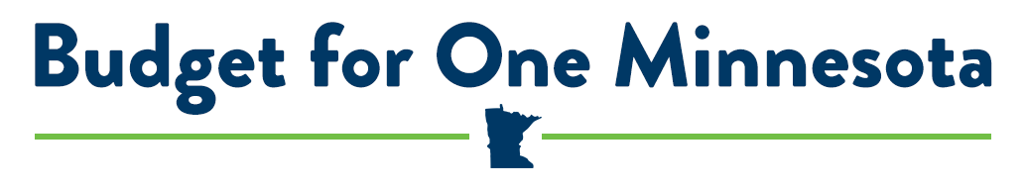

EVOLVING WORKFORCE NEEDS: HIGHER EDUCATION
The evidence is clear that some level of college completion is more important than ever, both to meet today’s changing workforce needs and for the economic security and well-being of Minnesota residents. But college feels out of reach for too many Minnesota students. To meet the goals and needs of a diverse student population, Governor Walz has proposed an umbrella of investments in programs to increase affordability, access and readiness to postsecondary education and training in Minnesota.

Minnesota has always been a leader in postsecondary education and an educated workforce. To maintain this legacy, challenges such as the high cost of college, crippling student debt and persistent attainment gaps for students of color and indigenous students must be addressed. The comprehensive Higher Education budget plan would help every student, regardless of age, race, income or where they live, complete their education and be successful in work.

AFFORDABILITY AND COMPLETION

Build on a strong foundation with the Minnesota State Grant Program
Governor Walz’s budget proposal prioritizes affordability for low and middle-income students and families with a significant investment in the Minnesota State Grant.
- 81,000 current State Grant recipients will receive an average grant increase of $300 to cover tuition and fees, and living and miscellaneous expenses.
- 4,700 new grant recipients will become eligible for help with college costs.
- The State Grant investment, combined with Federal Pell grants, covers the cost of tuition and fees for fulltime students at both Minnesota State 2-year colleges and 4-year universities for students from families making up to $45,000 a year.
- Close to 40% of State Grant recipients are students of color or indigenous students, helping to close the attainment gap for those populations.
- Increased State Grant awards for 500 Minnesota Dreamers and other underserved students will improve their ability to enroll in and complete a postsecondary education.

Support education, research and outreach at the University of Minnesota
Governor’s Walz’s budget supports a high-quality education at the University of Minnesota with a 3 percent increase in base appropriations. This funding enhances the missions of research and discovery, teaching and learning, and outreach and public service at all five University of Minnesota campuses. Infrastructure at the University of Minnesota is supported through a robust and comprehensive bonding bill totaling $150 million.

Prepare Minnesota students for success with a high quality, affordable education at Minnesota State Colleges and Universities
Governor Walz’s budget supports a high-quality, affordable education at Minnesota State Colleges and Universities with a 3.6 percent increase in base appropriations. Seven four-year universities and thirty two-year community and technical colleges blanket the state, providing Minnesotans with the opportunity to attend college close to home. These colleges play a lead role in career and technical education, helping to meet the changing needs of our workforce. The Capital Investment bill supports infrastructure and campus improvements by funding $150 million in state bonding requests.

TARGETED PROGRAMS

Boost college completion for returning adult students
It is estimated that 10 percent of Minnesotans age 25-44 have enrolled in college but dropped out without completing a certificate or degree. The MN Reconnect program helps adult learners re-enroll and complete their college education. Support such as dedicated advising, financial assistance and improved campus services are offered to help students successfully complete their program. The investment in Governor Walz’s budget will double the number of eligible schools to eight Minnesota State college campuses statewide.
Expand “earn while you learn” training grants to employers
Changing workforce needs and shifting demographics are making it more difficult for employers to find the trained and skilled employees they need. By combining on-the-job training with classroom learning, Dual Training grants help employers develop their workforce, while providing employees the benefit of earning a paycheck while they learn new skills to be successful at their current job or into the future. The new investment will cover education and training related travel and housing for students and support increased employer demand in advanced manufacturing occupations.

Prepare underrepresented students for college and career
The Intervention for College Attendance Program (ICAP) provides grants to programs that foster academic success and ensure underrepresented students are prepared for college and a career. The increased investment in Governor Walz’s budget will enable the grant program to reach more students, target specific underserved student populations and deepen services to current grant participants.

Limit Summer Melt for low-income students
Summer vacation takes a toll on students’ knowledge and skills; underserved students are especially vulnerable to this summer melt, and, over years, find it difficult to catch up. The funding increase in the higher education budget for the Summer Academic Enrichment Program will allow as many as 250 underserved elementary and secondary students to attend an approved academic summer program. These rigorous learning programs will help them improve their academic skills and prepare them to continue their education after high school.

MAINTAINING CRITICAL INFRASTRUCTURE

Expand the Statewide Longitudinal Education Data System (SLEDS) and Early Childhood Longitudinal Data System (ECLDS)
SLEDS and ECLDS are central to measuring outcomes of Minnesota students and the performance of state programs. SLEDS and ELCDS data enable policymakers, educators and parents to make informed decisions related to college and career paths and identify barriers to education and employment success.

Protect MinnState student records with ISRS Next Generation
The Governor’s budget invests $8 million to support a new data system for Minnesota State colleges and universities and their students, faculty and staff. ISRS Next Generation replaces a worn system that can no longer meet the needs of the campuses it serves. Its impact will be widespread, from system finance and accounting, to a student system that will support applications, registration, financial aid, housing and more.

Bonding Bill
While not part of the Higher Education budget bill, the Capital Investment bill provides significant funding for projects on Minnesota’s public colleges and universities campuses. These investments place a down payment on the future of our institutions of higher education.
Minnesota State
- $150 million investment for HEAPR projects at Minnesota State campuses
- Funds 100% of the State Capital Request
University of Minnesota
- Fully funded request of $28 million for the Child Development building replacement on the Twin Cities campus
- Fully funds request of $4.3 million for the renovation of A.B. Anderson Hall on the Duluth campus
- $117,700 million for HEAPR projects

