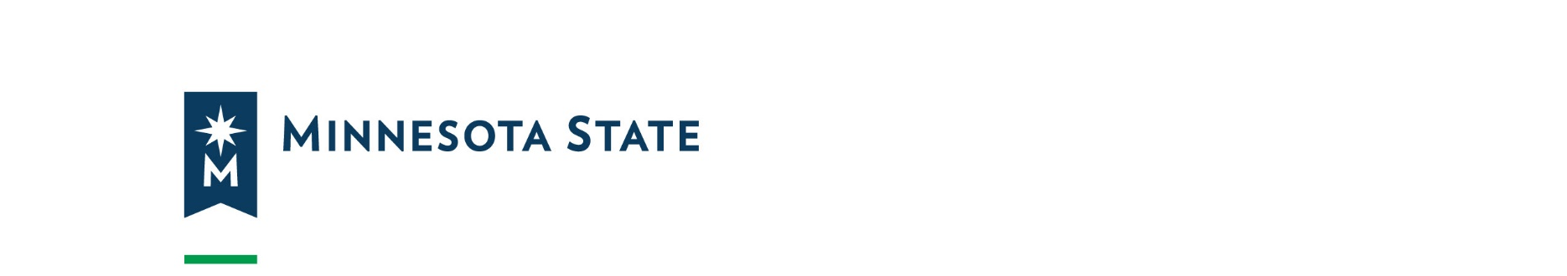
Supporting Minnesota High School Certified Nursing Assistants (CNA) Programs Equipment Grant - FY2023 Application Template

Application Coversheet

Applicant Information
Legal name of applicant organization:
District or Charter school organization number:
Total grant request:

Required Identification Numbers
Minnesota SWIFT vendor ID number (Tax ID):
Federal DUNS number:

Contact Information

Identified Official with Authority (IOWA) to Sign
Instructions: Enter the contact information of the person who will sign the application in the signature section.
Name of official with authority to sign:
Title:
Address:
City, state and zip code + 4:
Phone number:
Email:

Primary Program (PM) Contact Information
Name of Program Contact:
Title:
Address:
City, state and zip code:
Phone number:
Email:

Business Manager (BM) Contact Information
Name of business manager:
Title:
Address:
City, state and zip code:
Phone number:
Email:

Signature Section
Submit the completed and signed application coversheet, along with the application narrative by email not later than 5:00 p.m. CST on Friday, December 16, 2022:
Institution: Minnesota State
Name: LeAnn Snidarich
Title: Program Manager, Workforce Solutions
E-mail address: leann.snidarich@minnstate.edu

Signature and Date of the Official with Authority to sign
By signing below, I certify I have read the application (narrative, assurances, budget and supplemental documents, if applicable) and will comply with the approved application and assurances herein and additional state, local, federal regulations and policies that apply to my organization.
Name:
Date:
Signature: ___________________________________________________

Programmatic Assurances
- We will administer this program in accordance with all applicable statutes, regulations, program plans, and applications.
- The control of funds provided to this local educational agency under this program will be in a public agency, and a public agency will administer those funds and property.
- We will use fiscal control and fund accounting procedures that will ensure proper disbursement of, and accounting for, funds paid to us under this program.
- We will make reports to Minnesota State, the Minnesota Office of Higher Education, and the Minnesota Department of Education, as requested or required.
- Comply with the Minnesota Department of Health’s (MDH) on the CNA program curriculum and instructor Registry requirements.
- Use the grant purchased equipment only for CNA courses.
- Use the grant funds to purchase MDE/MDH approved equipment.
- Grantees shall consider applicable vendors from the targeted groups, economically disadvantaged and veteran-owned vendor list. Refer to the State Department of Administration's Certified Targeted Group, Economically Disadvantaged and Veteran-Owned Vendor List.
- Metropolitan Council’s Targeted Vendor list: Minnesota Unified Certification Program.
- Small Business Certification Program through Hennepin County, Ramsey County, and City of St. Paul: Central Certification Program

Application Narrative Section
Develop your narrative below for each required component. Include a separate header for each section of required content. Refer back to the Format of Proposals and Submission section of the Request for Proposal NGNA HA Equipment for specifics. Your complete application should consist of the following:

Statement of Need
Please provide a brief statement of need based on the goals of the project and how your district plans to utilize funds to support your approved Nursing Assistant program. Describe the need for new or upgraded equipment and supplies.

Narrative Answer for Statement of Need

How many students completed the Nursing Assistant class in academic years 2017-2018, 2018-2019, 2019-2020, 2020-2021, and 2021-2022? If available, please provide the number of students taking the NATO exam and the number passing the certification exam. If you do not have this data, please estimate as best you can.
Students in Nursing Assistant class/es
2018-2019
2019-2020
2020-2021
2021-2022

Students Taking NATO Exam
2018-2019
2019-2020
2020-2021
2021-2022

Students Passing NATO Exam
2018-2019
2019-2020
2020-2021
2021-2022

Diversity and Equity
Describe how nursing assistant classes center diversity, equity and inclusion.

Narrative Answer for Diversity and Equity

Capacity of the Applicant District
Describe your district’s MDH approved CNA program in your high school. Specifically respond to: Approximately how many students do you have interested in the next 12 months and how many could your district train during this period?

Narrative Answer for Capacity of the Applicant District

Project Goals, Community Partnerships, Strategies, and Outcomes
How does your Nursing Assistant program interact with your community and long-term care facilities? What type of support do you receive from long-term care facilities? What plans do you have in place, or how would you, increase enrollment in nursing assistant classes? How would these equipment funds help you meet the workforce needs in your region?

Narrative Answer for Project Goals, Community Partnerships, Strategies, and Outcomes

Budget
Please include a list of the equipment you will purchase with the Supporting Minnesota High School Certified Nursing Assistant (CNA) Program Equipment funds. The following link provides information on the most common types of equipment for CNA programs.
Equipment– https://www.health.state.mn.us/facilities/providers/nursingassistant/docs/equipmentlist.pdf
Please attach an excel spreadsheet or a table with the following information:
List of Equipment, Estimated Cost, Equipment Vendor, Purpose

